APPENDIX
A Markov Chain Model for Lifetime Risk of Diabetes by BMI
The Markov chain governing the movement of people among the three age-specific states⎯no diabetes, diabetes, and death⎯with age = a, a+1,…, A, A+1 years is defined by the transition matrix
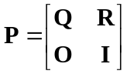
where O and I are conformable zero and identity matrices and
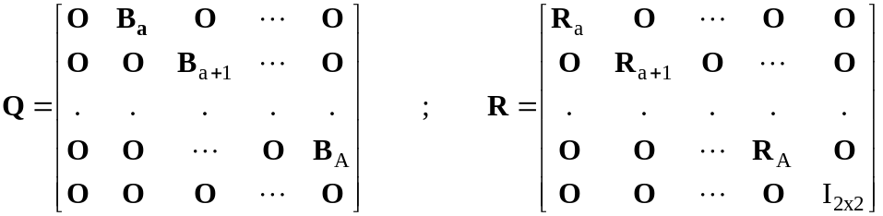
with 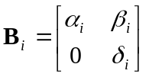, 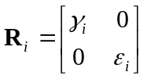. The parameters are defined by the following.
α_{i} = the probability of being non-diabetic a year later if non-diabetic at age = i years.
β_{i} = the probability of being diabetic a year later if non-diabetic at age = i years. These are the age-specific incidence rates for diagnosed diabetes.
γ_{i} = the probability of being dead a year later if non-diabetic at age = i years.
δ_{i} = the probability of being diabetic a year later if diabetic at age = i years.
ε_{i} = the probability of being dead a year later if diabetic at age = i years.
Clearly, the relations 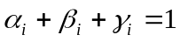 and 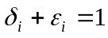 must hold for all ages i. The zero entries in the B matrices reflect the assumption that a person diagnosed with diabetes remains diabetic until death. Note that this specification ignores ages less than a minimum age = a years (a = 18 in our application), and “kills” people off at age = A+2 years (A+2 = 85). Hence, for this truncated model people are “born” at age = 18 and “death” is either dying before age = 85 or reaching age = 85. These transition rates are, for each of the eight race-sex groups, functions of age only. To extend this model so that lifetime risk and other related quantities are sensitive to BMI, modeling of the transition rates as functions of age and BMI category for each of the eight groups is required. Thus, the following specifications.
α (i,BMI_{j(i)}) = the probability of being non-diabetic a year later if non-diabetic at age i years in BMI category j.
β (i,BMI_{j(i)}) = the probability of being diabetic a year later if non-diabetic at age i years in BMI category j. These are the age- and BMI-specific incidence rates for diagnosed diabetes.
γ (i,BMI_{j(i)}) = the probability of being dead a year later if non-diabetic at age i years in BMI category j.
δ (i,BMI_{j(i)}) = the probability of being diabetic a year later if diabetic at age i years in BMI category j.
ε (i,BMI_{j(i)}) = the probability of being dead a year later if diabetic at age i years in BMI category j.

From the theory of Markov chains¹, the expected years of life remaining for a non-diabetic person whose age = i years is the sum of the elements in the (2i + 1)^{th} row of the matrix 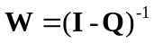 and the expected years of life with diabetes is the sum of the elements in the even columns of this row, where we adopt the convention that, henceforth, age = 0 corresponds to 18 years. For example, an 18-year-old without diabetes has an expected lifetime equal to the sum of the elements in the first row of W with expected years of life with diabetes (duration) equal to the sum of even columns in the first row of W. Also, the element u_{2i+1,2j+2} of the matrix 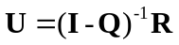, with j > i, equals the probability a person without diabetes whose age = i years will die with diabetes at age = j + 1 years. Thus, the following quantities are of interest.
Residual Lifetime Risk for Diabetes
The residual lifetime risk for diabetes for a non-diabetic person at age = i years is defined as the probability of dying with diabetes. Specifically,
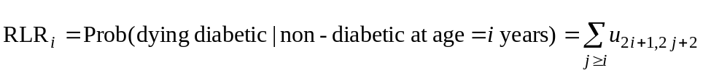
from the theory presented above.
Expected Remaining Lifetime and Duration of Diabetes
The expected remaining lifetime for people not diagnosed with diabetes at age = i years is, from the theory,
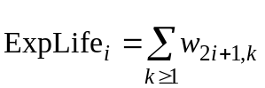
where the w’s are elements of the matrix W. The expected years of life with diabetes, or the duration of diabetes, is
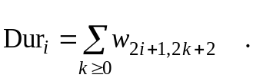
Derivation of Transition Probabilities
The following development was applied to each of the eight race-sex combinations for each given age = i years, where, to avoid notational clutter, all indices are suppressed except for BMI category j. For example, for white males age = 40 years we define the following.
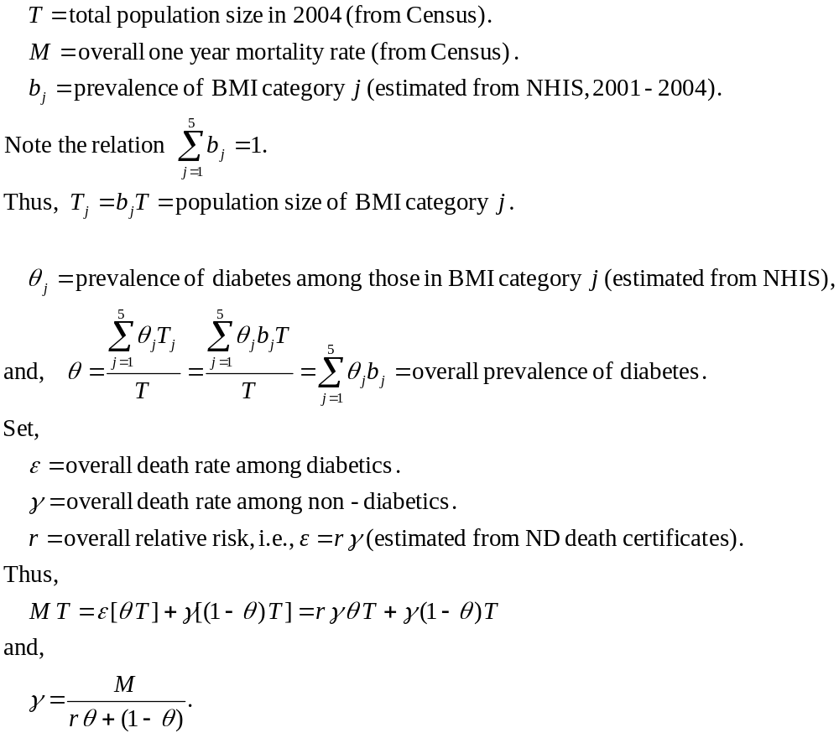
The additional estimates that were needed were relative risks of death by age group and BMI category and came from Flegal, et al. Since these were not reported by diabetes status we had to make the assumption they were the same for diabetics and non-diabetics. Specifically, we set
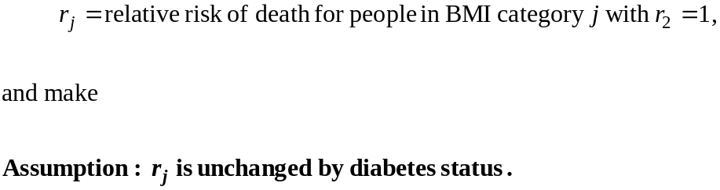
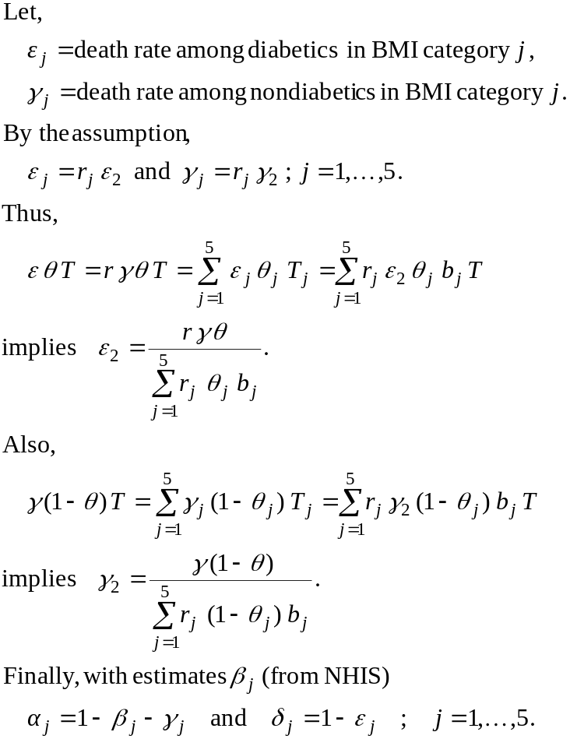
We can summarize all of the above. Given the inputs
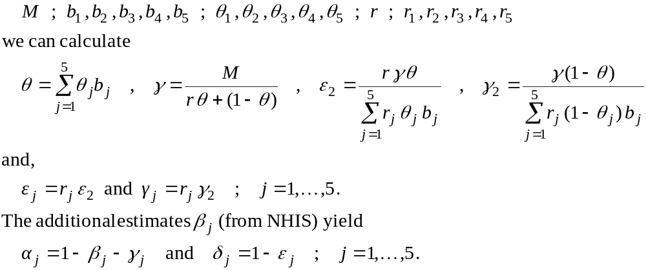
Estimation
A Bayesian approach was taken to estimate all transition probabilities and other quantities of interest in the Markov chain models. Markov Chain Monte Carlo (MCMC) methods were used to generate 5000 draws from the posterior distributions of prevalences, incidence rates, and relative risks of death attributable to diabetes. Five thousand normal “posterior” draws for the relative risk of death by age group and BMI category were produced using the estimates and standard errors from Flegal, et al. For our analysis we made the simplifying assumption that the overall population mortality rates from Census and the estimates of BMI prevalences from the National Health Interview Survey were estimated without error. Each posterior draw yielded, through the calculations described above, a posterior draw of all transition probabilities in the Markov models. Interestingly, for all 5000 draws, the following restrictions obtained for every age- race-sex combination:
This guaranteed 1) all chains were proper, i.e., all transition probabilities in the unit interval, and 2) all diabetes death rates were strictly greater than the corresponding non-diabetes death rate. Thus, none of the posterior draws were thrown out. The Markov chain models were then run 5000 times. The output from these runs provided the posterior distribution of all quantities of interest, e.g., lifetime risks, durations, etc. Posterior means were estimates of these quantities, and the 0.025 and 0.975 quantiles furnished 95 percent confidence intervals.

